2/2/2026
Product Feedback Intelligence & Roadmap Prioritization Engine
Capstone Project Proposal - Group 5

Table of Contents
1. Problem Statement 2
2. Project Objective 2
3. Scope of the Project 2
In Scope 2
Out of Scope 2
4. Dataset Description 2
5. How the System Works (High Level) 3
6. Project Phases 3
Phase 1 – Foundation 3
Phase 2 – Core Build 3
Phase 3 – Testing & Refinement 3
Phase 4 – Documentation 3
7. Tools & Technology Stack 3
8. Detailed Example 1 – Bug (Payment Failure) 4
Sample Feedback 4
Phase 1 – Foundation 4
Phase 2 – Core Build 4
Phase 3 – Testing & Refinement 4
Phase 4 – Documentation 5
9. Detailed Example 2 – Feature Request (Export to PDF) 5
Sample Feedback 5
Phase 1 – Foundation 5
Phase 2 – Core Build 5
Phase 3 – Testing & Refinement 5
Phase 4 – Documentation 6
10. Success Criteria 6
11. Expected Deliverables 6
12. Project Plan 6
13. Team 7
Team Members 7
Team Coordinator’s 7
14. Conclusion 7

1. Problem Statement
Product teams receive customer feedback from many places such as app reviews, surveys, and support messages. This feedback is unstructured and spread across sources, making it difficult to understand what customers really want. Because of this, product roadmap decisions are often based on assumptions rather than clear customer data.

2. Project Objective
The objective of this project is to build a simple AI-based system that collects customer feedback, identifies common problems and feature requests, and helps prioritize what should be built next using clear and explainable logic.

3. Scope of the Project

In Scope
- Use app store reviews as the main feedback source
- Add synthetic feedback to represent missing or low-volume feature requests
- Categorize feedback into bugs, feature requests, and usability issues
- Group similar feedback together
- Rank items based on importance
- Generate a suggested product roadmap

Out of Scope
- Live production deployment
- Integration with real company systems
- Revenue or financial forecasting

4. Dataset Description
- Primary dataset:
App Store Reviews dataset from Kaggle (fictional mobile application)
- Synthetic dataset:
Manually generated feedback for common product areas such as Login, Payments, Performance, UI/UX, Search, Notifications, and Export features.
- Additional information used:
Platform (Android/iOS), country, issue flag, likes, and dislikes to support grouping and prioritization.

5. How the System Works (High Level)
- Feedback is collected from datasets
- Feedback is classified into type (bug / feature / usability)
- Similar feedback is grouped together into themes
- Each theme is given a priority score
- A roadmap recommendation is generated with explanation

6. Project Phases

Phase 1 – Foundation
- Define scope and success criteria
- Prepare datasets and structure data
- Create prompt templates for classification and grouping

Phase 2 – Core Build
- Process feedback using workflows
- Identify issue type and feature area
- Group similar feedback
- Calculate priority scores

Phase 3 – Testing & Refinement
- Manually review classification and grouping
- Improve prompts for unclear feedback
- Handle feedback mentioning multiple issues

Phase 4 – Documentation
- Generate roadmap recommendations
- Prepare final summaries and documentation

7. Tools & Technology Stack
- Workflow Orchestration: N8N
- Language Models: GPT / Claude (via API)
- Prompt Flow Management: LangFlow
- Similarity & Grouping: Pinecone or in-memory embeddings
- Data Storage & Review: Google Sheets or Airtable or Notion
- Reporting: Generated summaries and tables

8. Detailed Example 1 – Bug (Payment Failure)

Sample Feedback
“The payment keeps failing after I enter my card details. I tried multiple times and had to stop using the app.”
Associated information:
- Platform: Android
- Country: India
- Star rating: 1
- Issue flag: Yes
- Likes: 5

Phase 1 – Foundation
- The feedback is stored in the dataset along with platform, country, and rating.
- Prompt templates are prepared to answer:
  - Is this a bug, feature request, or usability issue?
  - Which feature is affected?
Output of Phase 1:
The system is ready to process this feedback consistently.

Phase 2 – Core Build
- The feedback is classified as a Bug.
- The affected feature is identified as Payments.
- The system finds other similar feedback such as:
  - “Payment fails on checkout screen”
  - “Card transaction not going through”
- All related feedback is grouped under a single theme: Payment Failures.
- A high priority score is assigned because:
  - The issue appears multiple times
  - Star ratings are low
  - Users report being blocked from using the app

Phase 3 – Testing & Refinement
- The classification and grouping are manually reviewed.
- Prompts are refined if similar feedback is misclassified.
- Edge cases (feedback mentioning performance and payments together) are handled.
Output of Phase 3:
The grouping and priority score are validated.

Phase 4 – Documentation
- The system generates a roadmap recommendation:
“Fix payment failures as a top priority due to repeated customer complaints and high user impact.”
- Supporting evidence such as number of complaints and sample feedback is included.

9. Detailed Example 2 – Feature Request (Export to PDF)

Sample Feedback
“It would be very helpful if I could export my trip details as a PDF for record keeping.”
Associated information:
- Platform: iOS
- Country: UK
- Star rating: 4
- Issue flag: No

Phase 1 – Foundation
- Feedback is stored with basic details.
- Prompt templates are ready to detect feature requests.

Phase 2 – Core Build
- The feedback is classified as a Feature Request.
- The feature area is identified as Export.
- Similar feedback is grouped, such as:
  - “Need an option to download trip details”
  - “Export travel summary as PDF”
- The theme Export Functionality is created.
- A medium priority score is assigned because:
  - The request appears less frequently
  - Users are not blocked from using the app

Phase 3 – Testing & Refinement
- Duplicate or overlapping requests are reviewed.
- Grouping is adjusted if necessary.

Phase 4 – Documentation
- The system generates a roadmap recommendation:
“Add export to PDF feature as a medium-priority enhancement based on customer requests.”
- Justification is documented for product review.

10. Success Criteria
- All feedback is processed and categorized
- Clear and understandable themes are identified
- Roadmap recommendations are easy to explain
- Manual effort in feedback analysis is reduced

11. Expected Deliverables
- A working prototype showing feedback-to-roadmap flow
- A technical report explaining the approach and decisions
- A summary of insights and roadmap priorities

12. Project Plan
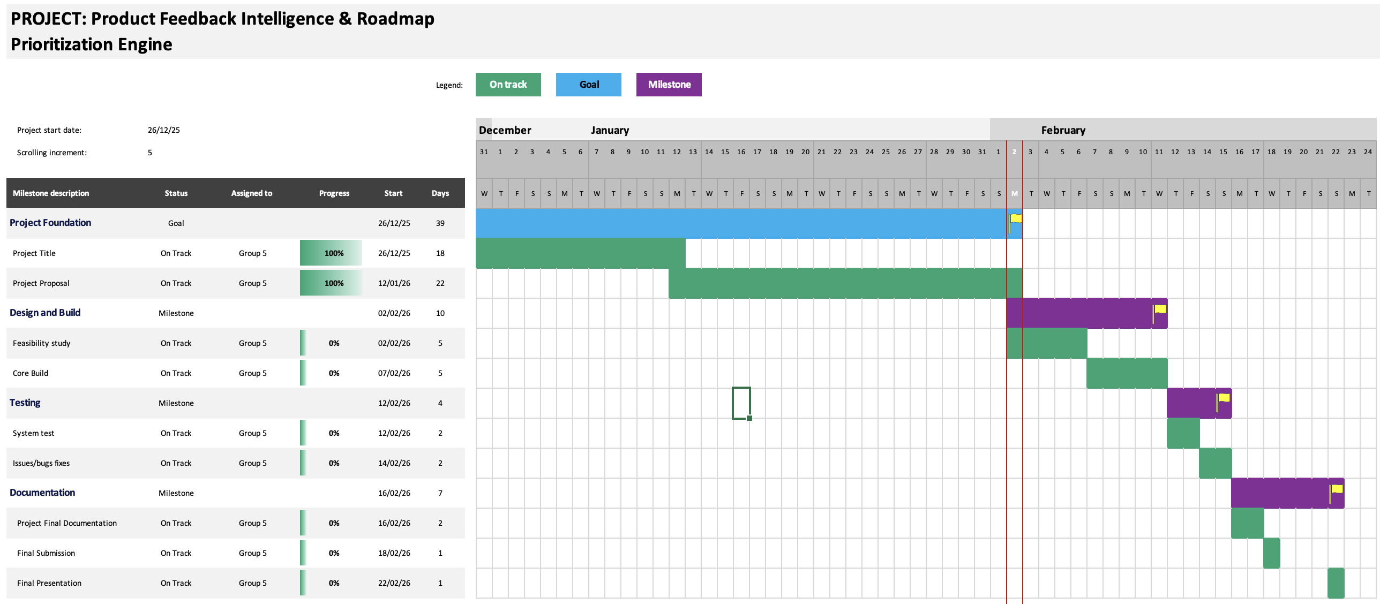

13. Team

Team Members
# | Team Members
1 | Chandra Sahithi
2 | Sushith M
3 | Sandana Mahesh
4 | Rishi Saxena
5 | Pratik Sharma

Team Coordinator’s
# | Team Members
1 | Rishi Saxena
2 | Pratik Sharma

14. Conclusion
This project demonstrates a practical and explainable approach to using AI for product feedback analysis and roadmap planning. The focus is on clarity, simplicity, and real-world usefulness rather than complex or experimental techniques.

